Практическое занятие 14.03

Тема: «HTML и CSS».

Выполнила Ермина С.Д. 4ИСИП-519

**HTML файл:**

<!DOCTYPE html>

<html lang="ru">

<head>

<meta charset="UTF-8">

<meta http-equiv="X-UA-Compatible" content="IE=edge">

<meta name="viewport" content="width=device-width, initial-scale=1.0">

<title>Задание 08.02</title>

<link rel="stylesheet" href="css/style.css"/>

<link rel="preconnect" href="https://fonts.googleapis.com">

<link rel="preconnect" href="https://fonts.gstatic.com" crossorigin>

<link href="https://fonts.googleapis.com/css2?family=PT+Sans+Caption:wght@400;700&display=swap" rel="stylesheet">

</head>

<body>

<header class="header">

<div class="header_countainer">

<div class="header_title">Ремонт <span>и</span> дизайн <span><br>в Москве и Московской области</span></div>

<div class="button_countainer">

<hr class="button_mark">

<a href="#" class="header_button">Оставить заявку</a>

</div>

</div>

<div class="header_nav_countainer">

<ul class="header_nav">

<li><a href="#" class="nav_button">Услуги по ремонту</a></li>

<li><a href="#" class="nav_button">Виды работ</a></li>

<li><a href="#" class="nav_button">Дизайн интерьера</a></li>

<li><a href="#" class="nav_button">Ремонт помещений</a></li>

</ul>

<img src="img/down.png" class="down_img">

</div>

</header>

<main class="page">

<section class="intro">

<div class="intro_countainer">

<hr class="intro_mark">

<div class="intro_title">Примеры <span>выполненных</span> работ</div>

</div>

<div class="grid_countainer">

<div class="grid">

<div class="box1_img">

<div class="text_img">Новостройка</div>

</div>

<div class="box2_img">

<div class="text_img">Новостройка</div>

</div>

<div class="box3_img">

<div class="text_img">Новостройка</div>

</div>

<div class="box4_img">

<div class="text_img">Новостройка</div>

</div>

<div class="box5_img">

<div class="text_img">Вторичка</div>

</div>

<div class="box6_img">

<div class="text_img">Вторичка</div>

</div>

<div class="box7_img">

<div class="text_img">Вторичка</div>

</div>

<div class="box8_img">

<div class="text_img">Вторичка</div>

</div>

</div>

</div>

<div class="button_intro_countainer">

<hr class="button_mark">

<a href="#" class="intro_button">Все проекты</a>

</div>

</section>

</body>

</html>

**CSS файл:**

* {

margin: 0;

padding: 0;

}

body {

font-family: 'PT Sans Caption', sans-serif;

}

.header_title span {

color: white;

-webkit-text-stroke: 1.5px black;

}

.intro_title span {

color: white;

-webkit-text-stroke: 0.5px black;

}

.header_countainer {

display: flex;

flex-direction: column;

flex-wrap: wrap;

justify-content: center;

align-items: center;

height: 725,5px;

width: 100%;

padding-top: 65.5px;

}

.header_title {

height: 144px;

width: 1200px;

box-sizing: border-box;

font-style: normal;

font-weight: 700;

font-size: 64px;

line-height: 72px;

text-align: center;

color: #222222;

margin-bottom: 48px;

}

.button_countainer {

height: 40px;

display: flex;

flex-direction: row;

flex-wrap: wrap;

justify-content: center;

margin-bottom: 84px;

}

.header_button {

place-items: center;

width: 207px;

height: 40px;

display: inline-flex;

justify-content: center;

align-items: center;

box-sizing: border-box;

text-decoration: none;

background-color: transparent;

border: 1px solid #2222224D;

font-style: normal;

font-weight: 700;

font-size: 14px;

line-height: 20px;

color: #222222;

}

.button_mark {

height: 1px;

width: 24px;

margin-top: 20px;

margin-right: -10px;

text-align: center;

background: #222222;

border: 1px #222222;

}

.header_nav_countainer {

width: 100%;

height: 344px;

display: flex;

flex-direction: column;

background: linear-gradient(0deg, rgba(0, 0, 0, 0.3), rgba(0, 0, 0, 0.3)),

url(../img/title.png);

background-size: cover;

justify-content: space-evenly;

align-items: center;

}

ul {

width: 100%;

height: 85px;

align-items: center;

text-align: center;

list-style-type: none;

display: table;

padding-top: 173px;

}

ul li {

padding-top: 31px;

display: table-cell;

font-style: normal;

font-weight: 700;

font-size: 20px;

line-height: 24px;

border: 1px solid #FFFFFF4D;

}

a {

color: white;

text-align: center;

align-items: center;

place-items: center;

place-content: center;

text-decoration: none;

}

.down_img {

width: 40px;

height: 40px;

}

.intro_countainer {

height: 40px;

display: flex;

flex-direction: row;

flex-wrap: wrap;

justify-content: center;

margin-top: 64.5px;

margin-bottom: 48px;

margin-right: 683px;

}

.intro_title {

width: 500px;

height: 40px;

box-sizing: border-box;

font-style: normal;

font-weight: 700;

font-size: 32px;

line-height: 40px;

margin-left: 80px;

color: #222222;

}

.intro_mark {

height: 0px;

width: 40px;

margin-top: 20px;

margin-right: -40px;

text-align: center;

color: #222222;

}

.grid_countainer {

display: flex;

justify-content: center;

align-items: center;

width: 100%;

height: auto;

}

.grid {

display: grid;

box-sizing: border-box;

gap: 10px;

justify-items: center;

align-items: center;

justify-content: center;

align-content : center;

place-items: center;

grid-template-areas:

"A A B"

"E J B"

"D G F"

"D C C";

}

.text_img {

margin-top: 32px;

margin-left: 32px;

color: white;

font-style: normal;

font-weight: 700;

font-size: 20px;

line-height: 24px;

}

.box1_img {

grid-area: A;

height: 270px;

width: 730px;

background: linear-gradient(0deg, rgba(0, 0, 0, 0.5) 0%, rgba(0, 0, 0, 0) 100%),

linear-gradient(0deg, rgba(0, 0, 0, 0.1), rgba(0, 0, 0, 0.1)),

url(../img/nb_1.png) 0 0;

}

.box2_img {

grid-area: B;

height: 550px;

width: 360px;

background: linear-gradient(0deg, rgba(0, 0, 0, 0.5) 0%, rgba(0, 0, 0, 0) 100%),

linear-gradient(0deg, rgba(0, 0, 0, 0.1), rgba(0, 0, 0, 0.1)),

url(../img/nb_2.png) 0 0;

}

.box3_img {

grid-area: C;

height: 270px;

width: 730px;

background: linear-gradient(0deg, rgba(0, 0, 0, 0.5) 0%, rgba(0, 0, 0, 0) 100%),

linear-gradient(0deg, rgba(0, 0, 0, 0.1), rgba(0, 0, 0, 0.1)),

url(../img/nb_3.png) 0 0;

}

.box4_img {

grid-area: D;

height: 550px;

width: 360px;

background: linear-gradient(0deg, rgba(0, 0, 0, 0.5) 0%, rgba(0, 0, 0, 0) 100%),

linear-gradient(0deg, rgba(0, 0, 0, 0.1), rgba(0, 0, 0, 0.1)),

url(../img/nb_4.png) 0 0;

}

.box5_img {

grid-area: E;

height: 270px;

width: 360px;

background: linear-gradient(0deg, rgba(0, 0, 0, 0.5) 0%, rgba(0, 0, 0, 0) 100%),

linear-gradient(0deg, rgba(0, 0, 0, 0.1), rgba(0, 0, 0, 0.1)),

url(../img/s_1.png) 0 0;

}

.box6_img {

grid-area: F;

height: 270px;

width: 360px;

background: linear-gradient(0deg, rgba(0, 0, 0, 0.5) 0%, rgba(0, 0, 0, 0) 100%),

linear-gradient(0deg, rgba(0, 0, 0, 0.1), rgba(0, 0, 0, 0.1)),

url(../img/s_2.png) 0 0;

}

.box7_img {

grid-area: G;

height: 270px;

width: 360px;

background: linear-gradient(0deg, rgba(0, 0, 0, 0.5) 0%, rgba(0, 0, 0, 0) 100%),

linear-gradient(0deg, rgba(0, 0, 0, 0.1), rgba(0, 0, 0, 0.1)),

url(../img/s_3.png) 0 0;

}

.box8_img {

grid-area: J;

height: 270px;

width: 360px;

background: linear-gradient(0deg, rgba(0, 0, 0, 0.5) 0%, rgba(0, 0, 0, 0) 100%),

linear-gradient(0deg, rgba(0, 0, 0, 0.1), rgba(0, 0, 0, 0.1)),

url(../img/s_4.png) 0 0;

}

.container_img {

display: grid;

place-items: center;

}

.button_intro_countainer {

height: 60px;

display: flex;

flex-direction: row;

flex-wrap: wrap;

justify-content: center;

padding-top: 64px;

padding-bottom: 20px;

}

.intro_button {

place-items: center;

width: 182px;

height: 40px;

display: inline-flex;

justify-content: center;

align-items: center;

box-sizing: border-box;

text-decoration: none;

background-color: transparent;

border: 1px solid #2222224D;

font-style: normal;

font-weight: 700;

font-size: 14px;

line-height: 20px;

color: #222222;

}

Рисунок 1. Макет сайта

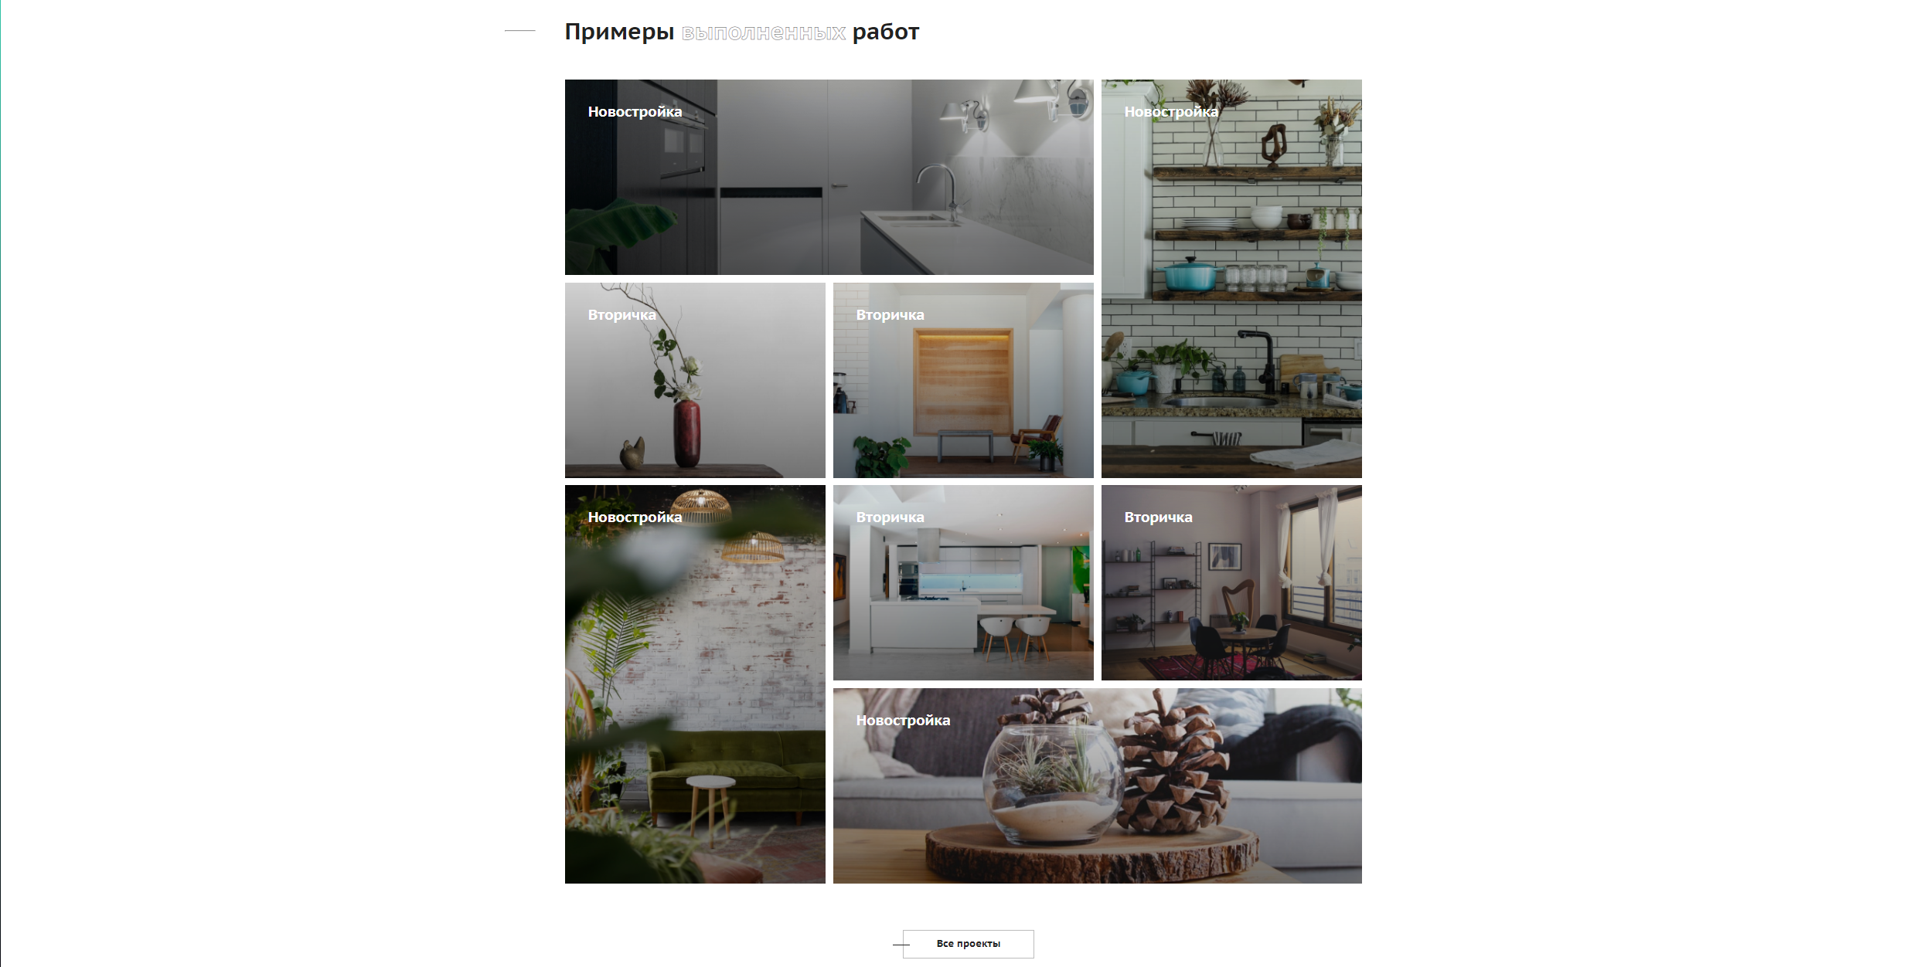

Рисунок 2. Макет сайта